1. Create Java classes having suitable attributes for Library management system.Use OOPs concepts in your design.Also try to use interfaces and abstract classes.
package java2;
abstract class IssuedOn {
abstract String issue_on(String In);
abstract String issue_till(String It);
}
interface Book {
String bookName(String bn);
String authorName(String an);
}
class Person extends IssuedOn implements Book {
String Name;
@Override
public String bookName(String bn) {
return bn;
}
@Override
public String authorName(String an) {
return an;
}
@Override
public String issue_on(String In) {
return In;
}
@Override
public String issue_till(String It) {
return It;
}
}
class Library extends Person {
public static void main(String[] args) {
Person p1=new Person();
p1.Name="Nirbhay";
System.out.println("Student Name :"+p1.Name+"\nBook_name: "+p1.bookName("Book1")+"\nAuthor Name: "+p1.authorName("John"));
System.out.println("Issued on : "+p1.issue_on("15-feb-2020")+" till "+p1.issue_till("7")+" days.");
}
}
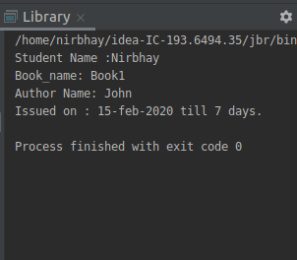

2. WAP to sorting string without using string Methods?
package java2;
public class q2 {
public static void main(String[] args) {
String a="hello";
int i,j;
char temp;
char arr[]= a.toCharArray();
for(i=0;i<arr.length;i++)
{
for (j=0;j<arr.length;j++)
{
if (arr[i]<arr[j])
{
temp=arr[i];
arr[i]=arr[j];
arr[j]=temp;
}
}
}
String b=new String(arr);
System.out.println(b);
}
}

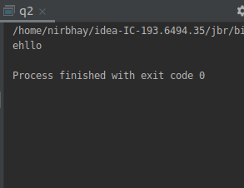

3. WAP to produce NoClassDefFoundError and ClassNotFoundException exception.
class abc
{
void disp()
{
System.out.println("hello!");
}
}

class a {
public static void main(String args[])
{
abc obj = new abc();
obj.disp();
}
}

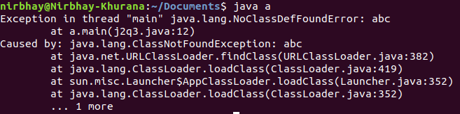

package java2;
public class q3 {
public static void main(String args[]) {
try
{
Class.forName("abc");
}
catch (ClassNotFoundException ex)
{
ex.printStackTrace();
}
}
}

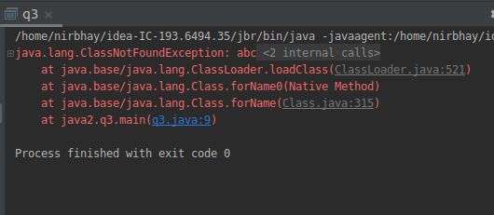
4. WAP to create singleton class.
package java2;
class singleton
{
static singleton ins=null;
public String str;
private singleton()
{
str="hello";
}
public static singleton getInstance()
{
if (ins==null)
{
ins=new singleton();
}
return ins;
}
}
public class q4 {
public static void main(String[] args) {
singleton obj1=singleton.getInstance();
singleton obj2=singleton.getInstance();
obj2.str="hi";
System.out.println(obj1.str);
System.out.println(obj2.str);
}
}

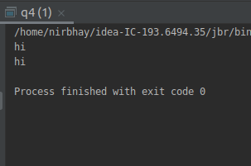

5. WAP to show object cloning in java using cloneable and copy constructor both.
package java2;
class a1
{
int x,y;
}
class a2 implements Cloneable
{
int a,b;
a1 obj1=new a1();
public Object clone() throws CloneNotSupportedException
{
return super.clone();
}
}
public class q5 {
public static void main(String[] args) throws CloneNotSupportedException{
a2 obj2=new a2();
obj2.a=10;
obj2.b=20;
obj2.obj1.x=30;
obj2.obj1.y=40;
a2 obj3= (a2) obj2.clone();
obj3.a=25;
obj3.obj1.x=45;
System.out.println(obj2.a+" "+obj2.b+" "+obj2.obj1.x+" "+obj2.obj1.y);
System.out.println(obj3.a+" "+obj3.b+" "+obj3.obj1.x+" "+obj3.obj1.y);
}
}

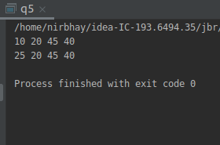

package java2;
public class q5p2 {
int id;
String name;
q5p2(int id, String name)
{
this.id = id;
this.name = name;
}
public q5p2(q5p2 o1) {
id = o1.id;
name = o1.name;
}
public static void main(String[] args) {
q5p2 obj1=new q5p2(101,"nirbhay");
q5p2 obj2=new q5p2(obj1);
System.out.println(obj1.id + " " + obj1.name);
System.out.println(obj2.id + " " + obj2.name);
}
}

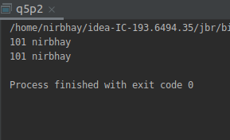

6. WAP showing try, multi-catch and finally blocks.
package java2;
public class q6 {
public static void main(String[] args) {
try{
System.out.println(10/0);
}
catch(ArithmeticException e)
{
System.out.println("Cant divide by zero");
}
catch(ArrayIndexOutOfBoundsException e)
{
System.out.println("Insertion more than required");
}
finally
{
System.out.println("finally block");
}
}
}

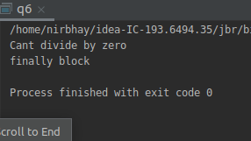

7. WAP to convert seconds into days, hours, minutes and seconds.
package java2;
public class q7 {
static void convert(int n)
{
int day = n / (24 * 3600);
n = n % (24 * 3600);
int hour = n / 3600;
n %= 3600;
int minutes = n / 60 ;
n %= 60;
int seconds = n;
System.out.println( day + " " + "days " + hour + " " + "hours " + minutes + " " + "minutes " + seconds + " "
+ "seconds ");
}
public static void main(String[] args) {
int n = 150003;
convert(n);
}
}
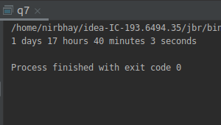

8. WAP to read words from the keyboard until the word done is entered. For each word except done, report whether its first character is equal to its last character. For the required loop, use a
a)while statement
b)do-while statement

package java2;
import java.util.Scanner;
public class q8 {
public static void main(String[] args) {
String str=null;
Scanner obj=new Scanner(System.in);
str=obj.next();
while(!str.equals("done")){
if(str.charAt(0) == str.charAt(str.length()-1))
{
System.out.println("First and last character are equals");
}
else
{
System.out.println("First and last character are not equals");
}
str=obj.next();
}
do {
if(str.charAt(0) == str.charAt(str.length()-1))
{
System.out.println("First and last character are equals");
}
else
{
System.out.println("First and last character are not equals");
}
str=obj.next();
}
while(!str.equals("done"));
}
}

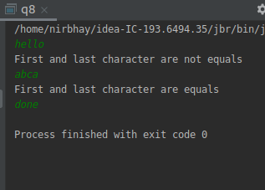

9. Design classes having attributes for furniture where there are wooden chairs and tables, metal chairs and tables. There are stress and fire tests for each products.
package java2;
abstract class furniture {
public abstract boolean checkStress();
public abstract boolean checkfire();
}
class chair extends furniture{
String type;
boolean fire;
boolean stress;
public chair(String t, boolean f, boolean s)
{
this.type=t;
this.fire=f;
this.stress=s;
}
@Override
public boolean checkStress()
{
return stress;
}
@Override
public boolean checkfire() {
return fire;
}
}
class table extends furniture{
String type;
boolean fire;
boolean stress;
public table(String t, boolean f, boolean s)
{
this.type=t;
this.fire=f;
this.stress=s;
}
@Override
public boolean checkStress()
{
return stress;
}
@Override
public boolean checkfire() {
return fire;
}
}
public class q9 {
public static void main(String[] args) {
chair ch = new chair("wooden", true, true);
table tb = new table("metal", true, true);
System.out.println("For CHAIR--");
System.out.println("Type is: "+ch.type);
System.out.println("Stress test : "+ch.checkStress());
System.out.println("Fire test : "+ch.checkfire());
System.out.println("*********************************");
System.out.println("For TABLE--");
System.out.println("Type is: "+tb.type);
System.out.println("Stress test: "+tb.checkfire());
System.out.println("Fire test: "+tb.checkStress());
}
}
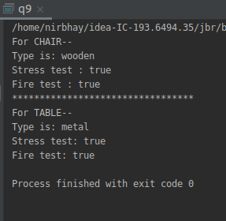

10. Design classes having attributes and method(only skeleton) for a coffee shop. There are three different actors in our scenario and i have listed the different actions they do also below
* Customer
- Pays the cash to the cashier and places his order, get a token number back
- Waits for the intimation that order for his token is ready
- Upon intimation/notification he collects the coffee and enjoys his drink
( Assumption: Customer waits till the coffee is done, he wont timeout and cancel the order. Customer always likes the drink served. Exceptions like he not liking his coffee, he getting wrong coffee are not considered to keep the design simple.)
* Cashier
- Takes an order and payment from the customer
- Upon payment, creates an order and places it into the order queue
- Intimates the customer that he has to wait for his token and gives him his token
( Assumption: Token returned to the customer is the order id. Order queue is unlimited. With a simple modification, we can design for a limited queue size)
* Barista
- Gets the next order from the queue
- Prepares the coffee
- Places the coffee in the completed order queue
- Places a notification that order for token is ready

public class CoffeeShop {
public static void main(String[] args) {
}
}
class Customer
{
static int token;
int i=0;
int placeOrder(double csh)
{
return token;
}
int wait(int time)
{
return time;
}
}
class Cashier
{
void getOrder(double cash){}
void CreateOrder(int arr[]){}
}
class Barista
{
void NextOrder(int oder){}
int[] OrderReady(int arr[])
{
return arr;
}
void notification(){}
}

11. Convert the following code so that it uses nested while statements instead of for statements:
int s = 0;
int t = 1;
for (int i = 0; i < 10; i++)
{
s = s + i;
for (int j = i; j > 0; j−−)
{
t = t * (j - i);
}
s = s * t;
System.out.println("T is " + t);
}
System.out.println("S is " + s);

package java2;
public class q11 {
public static void main(String[] args) {
int s = 0;
int t = 1;
int i=0,j;
while(i<10)
{
s = s + i;
j=i;
while (j>0)
{
t = t * (j - i);
j--;
}
s = s * t;
System.out.println("T is " + t);
i++;
}
System.out.println("S is " + s);
}
}

12.What will be the output on new Child(); ?
class Parent extends Grandparent {
{
System.out.println("instance - parent");
}
public Parent() {
System.out.println("constructor - parent");
}
static {
System.out.println("static - parent");
}
}
class Grandparent {
static {
System.out.println("static - grandparent");
}
{
System.out.println("instance - grandparent");
}
public Grandparent() {
System.out.println("constructor - grandparent");
}
}
class Child extends Parent {
public Child() {
System.out.println("constructor - child");
}
static {
System.out.println("static - child");
}
{
System.out.println("instance - child");
}
}

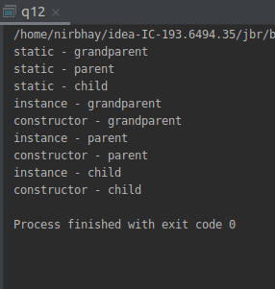

Q13. Create a custom exception that do not have any stack trace.

package java2;
class MyException extends Exception
{
boolean suppressStacktrace = false;
public MyException(String s1,Boolean suppressStacktrace)
{
super(s1,null,suppressStacktrace,!suppressStacktrace);
this.suppressStacktrace = suppressStacktrace;
}
}
public class q13 {
public static void main(String[] args)
{
try
{
throw new MyException("my exc",true);
}
catch (MyException ex)
{
System.out.println("caught exception");
}
}
}

